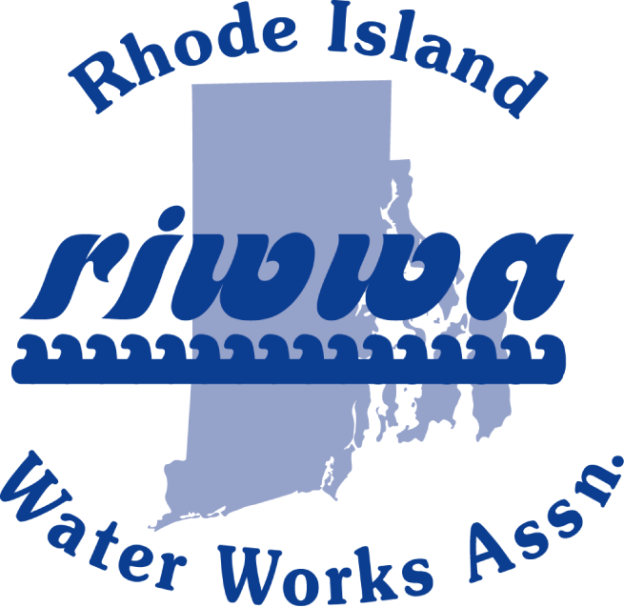

RIWWA

Thursday, March 12, 2020
Eleven Forty Nine
1149 Division Street – Warwick, RI 02818

9:00 – 9:15 AM Registration and Coffee

9:15 – 9:30 AM President’s Message

9:30– 11:00 AM Al Leblanc, PFAS Presentation
Speaker: TBA – LCR Revisions

11:15 – 11:30 Business Meeting/Legislative Update

11:30 – 12:00 Attitude Adjustment

12:15 PM Buffet - Lunch

Please visit www.riwwa.net to sign up for this informative event.

Event Price: $65.00

