RIWWA 43rd Annual Golf Tournament
The Rhode Island Water Works Association is holding its 43rd annual golf Tournament on Thursday, May 25, 2023 at the Valley Country Club. Registration and BBQ lunch from 11:00 AM-12:15 PM and a 12:30 PM Shotgun start. The cost per player is $150.00, which covers green fees, cart, barbecue lunch, and dinner.
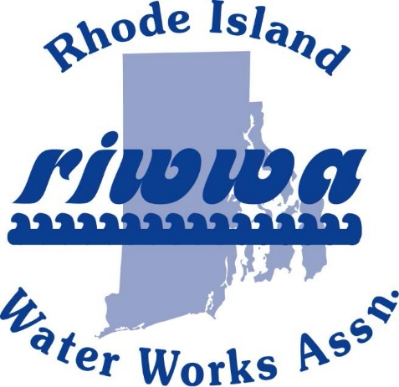

Valley Country Club 251 New London Ave. Warwick, RI 02886
Phone: 401-821-1115

Thursday May 25, 2023

$150.00 per player
$50 Dinner only
11:00 am – 12:15 pm Reg. and BBQ Lunch
Shotgun Start @ 12:30 pm

Scramble Format

Enjoy BBQ Lunch, 18 holes of golf (including cart), complimentary on-course beverages, apres-golf appetizers, raffle prizes, and buffet dinner!!!!!

Prizes will be awarded for:
Team Low and High Scores
Longest Drive - Men & Women
Closest to the pin - Men & Women
If anyone would like to donate a
prize, please contact James DeCelles at decelles@pwsb.org or Ken Difonzo at (401) 447-7333
Registration and payment must be submitted by Tuesday May 18, 2023.
Please make check payable to: RIWWA
Mail form and check to: P.O Box 216, West Kingston RI 02892

Player #1 Name:
Address:
City: State: Zip:
Cell Phone: Shirt Size:
E-Mail Address:
Payment: Cash: Credit Card: Check No.:
Visa: MasterCard: Discover: American Express:
Card Number:
Exp. Date: Security Code: Card Zip Code:
TEAM CONTACT PLAYER

Player #2 Name:
Cell Phone: Shirt Size:
E-Mail Address:
Payment: Cash: Credit Card: | Check No.:
Visa: MasterCard: Discover: | American Express:
Card Number:
Exp. Date: Security Code: | Card Zip Code:

Player #3 Name:
Cell Phone: Shirt Size:
E-Mail Address:
Payment: Cash: Credit Card: | Check No.:
Visa: MasterCard: Discover: | American Express:
Card Number:
Exp. Date: Security Code: | Card Zip Code:

Player #4 Name:
Cell Phone: Shirt Size:
E-Mail Address:
Payment: Cash: Credit Card: | Check No.:
Visa: MasterCard: Discover: | American Express:
Card Number:
Exp. Date: Security Code: | Card Zip Code:

