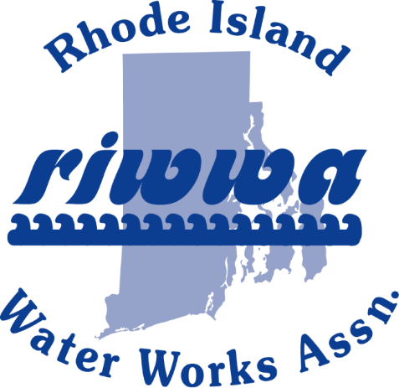

RIWWA 43rd Annual Golf Tournament

Sponsor Form
Valley Country Club
Thursday, May 25, 2023

RIWWA has the following sponsor opportunities for the 43rd Annual RIWWA Golf Tournament at Valley Country Club on Thursday, May 25, 2023. Anyone who would like to donate raffle prizes can bring them to the registration table on the day of the event. RIWWA appreciates the continued support of our sponsors in helping make this event a success!!!
Date: | Contact Name:
Company Name:
Mailing Address:
City: |  | State: | Zip:
Phone: |  | Cell Phone: | Fax:
E-Mail:

Sponsorship Levels:
Platinum Sponsor - $4000
Logo on tournament apparel and in-cart digital advertising
Dinner Sponsor - $300 (Limit of 6)
Sign with sponsor logos at each dinner station
Drink Cups $500 (Limit of 1)
Showcase your business log on beverage cups
BBQ Lunch Sponsor - $250 (Limit of 6)
Sign with sponsor logos at BBQ station
Post-Golf Appetizer Sponsor - $250 (Limit of 6)
Sign with sponsor logos in area of post-golf appetizer station
Golf Balls $1000 (Limit of 1)
Company logo on complimentary sleeve of golf balls
Tee Sponsor - $100 for 1st sign and $50 for each additional
Signs with sponsor logos in tee box
Please email logos to decelles@pwsb.org
Number of Signs Requested Tee sign amount $
Total Sponsor Amount $

E-mail your company logo to decelles@pwsb.org in a PDF or JPEG Format
Method Of Payment
Amount Paid: | Cash: | Credit Card: | Check No.:
Visa: | Master Card: | Discover: | American Express:
Card Number:
Expiration Date: |  | Security Code: | Card Zip Code:
Mail this form and payment to: RIWWA, P.O. Box 216, West Kingston, RI 02892
Confirmation and payment must be submitted by Friday, May 1, 2023
FIRST COME, FIRST SERVE ON SPONSORSHIPS

