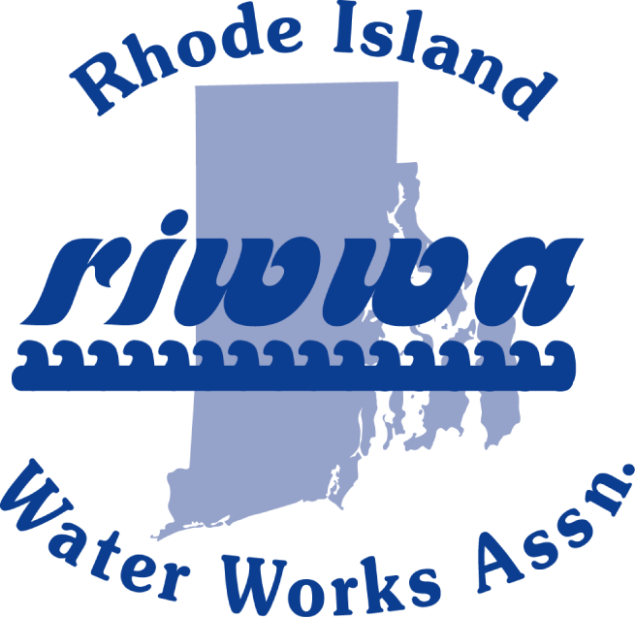

RIWWA
Thursday, December 12, 2019
Matunuck Oyster Bar
629 Succotash Road, South Kingstown

- 9:00 – 9:30 Registration and Coffee
- 9:30 – 9:45 President’s Message
- 10:00 – 10:45 Mike Hallock CEO, RI Mushroom Company
- 10:45 – 11:00 Melissa OrpenTuz, RI DOH Capacity Development Program Manager
- 11:00 – 11:15 Break
- 11:00 - 11:15 Legislative Update – Henry Meyer
- 11:15 – 11:30 Election of Officers, Business Meeting
- 11:30 – 12:00 Attitude Adjustment: Appetizers:
- Oyster Samplers, Pt. Judith Calamari & Chicken Fingers
- 12:00 Lunch ____________________________________________________________________________
Lunch Offerings to be selected the day of the event

VISIT: RIWWA.NET to register for the event.

