RIWWA 40th Annual Golf Tournament
The Rhode Island Water Works Association is holding its 40th annual golf Tournament on Thursday, October 15, 2020 at the Valley Country Club. Registration 8:00 am. The cost per player is $150.00, which covers green fees, cart, and dinner.
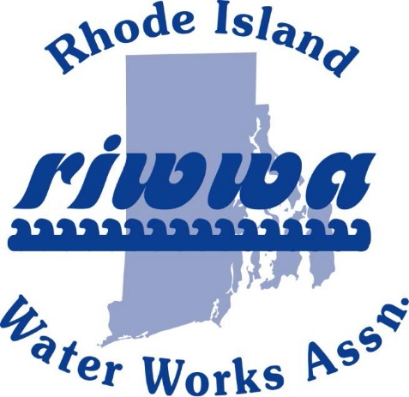

Valley Country Club 251 New London Ave. Warwick, RI 02886
Phone: 401-821-1115

Thursday, October 15

$150.00 per player
$45 Dinner only
8:00 am Registration followed Dinner

Scramble Format

18 holes (including cart), complimentary on-course beverages, apres golf appetizers, raffle prizes, and dinner.

Prizes will be awarded for:
Team Low and High Scores
Longest Drive - Men & Women
Closest to the pin - Men & Women
If anyone would like to donate a
prize, please contact James DeCelles at decelles@pwsb.org or Ken Difonzo at (401) 447-7333
Registration and payment must be submitted by Monday, September 21, 2020.
Please make check payable to: RIWWA
Mail form and check to: P.O Box 216, West Kingston RI 02892

Player #1 Name:
Address:
City: State: Zip:
Cell Phone: Shirt Size:
E-Mail Address:
Payment: Cash: Credit Card: Check No.:
Visa: MasterCard: Discover: American Express:
Card Number:
Exp. Date: Security Code: Card Zip Code:
TEAM CONTACT PLAYER

Player #2 Name:
Cell Phone: Shirt Size:
E-Mail Address:
Payment: Cash: Credit Card: | Check No.:
Visa: MasterCard: Discover: | American Express:
Card Number:
Exp. Date: Security Code: | Card Zip Code:

Player #3 Name:
Cell Phone: Shirt Size:
E-Mail Address:
Payment: Cash: Credit Card: | Check No.:
Visa: MasterCard: Discover: | American Express:
Card Number:
Exp. Date: Security Code: | Card Zip Code:

Player #4 Name:
Cell Phone: Shirt Size:
E-Mail Address:
Payment: Cash: Credit Card: | Check No.:
Visa: MasterCard: Discover: | American Express:
Card Number:
Exp. Date: Security Code: | Card Zip Code:

