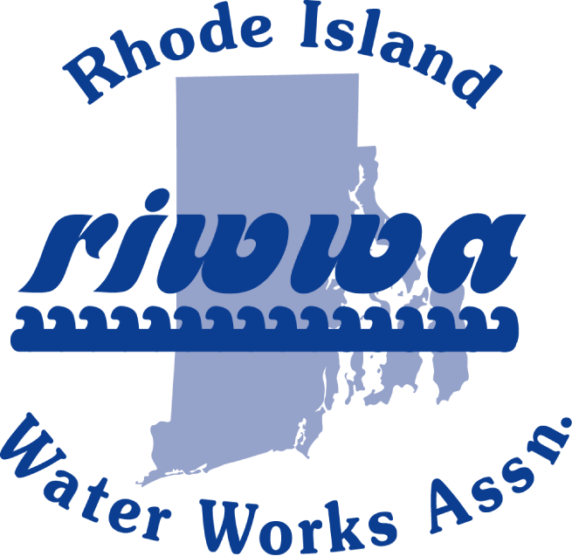
TRAINING DAY/EXPO
SEPTEMBER 15, 2022
Twelve Acres
445 Douglas Pike
Smithfield, RI 02817

Vendor Tables and Sponsorship Sign Up Sheet

Vendor Table Cost: $700 for a table, register before August 15, 2022 to be included on the registration form. This includes 2 meal tickets as well an additional display or demonstration in the parking lot. (Weather Permitting)

Sponsorship Cost: $200. This includes recognition of the vendor sponsor on the registration form (if registered before August 15, 2022) and a display board at the entrance to the training area.

Call Joe Coulter with any questions @ (978) 337-0525
Or Leanne Peckham @ (401) 783-5494
______________________________________________________________________________
Please detach here and remit to RIWWA C/O Kingston Water District
PO BOX 216, West Kingston, RI 02892

Company Name: ____________________________________________________________________________

Address/Phone: ____________________________________________________________________________

Please indicate Sponsorship _________ or Vendor Table _____________________

Vendor Table meal choice: Lobster____________ Steak_________ Chicken____________
2 tickets with purchase of vendor table.

(Deadline August 15, 2022 to be listed as a Sponsor on Registration Form)

WWW.RIWWA.NET

